Assignment No 2 ( LAB )

Name : Abdul Haq
Registration no : SP24-BSE-033
Course : Information Security
Date : 12th October 2025



Questions 1:
You have implemented DES there is built in implemented DES in python in
crypto cipher module use it for encryption/decryption and provide output sample

Answer:
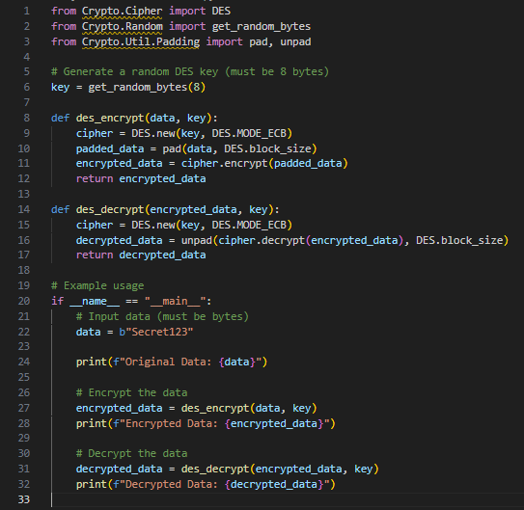
OutPut
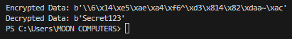

Question:
Describe the meet-in-the-middle (MITM) attack against double DES (2DES). Explain the attack steps, derive the time and memory complexity (with equations), list the assumptions required for the attack, and demonstrate the attack using the provided MITM demo script — include the recovered keys and the runtimes for the table-building and search phases. Conclude (≤50 words) why 2DES is insecure and give one recommended countermeasure.
Answer
Explanation :
Background and attack idea:
Double DES encrypts twice: C = E(K2, E(K1, P)). The meet-in-the-middle attack splits the work by computing E(K1, P) for every K1 and D(K2, C) for every K2, then searching for matches. A match yields candidate (K1, K2) pairs which are verified against the ciphertext.
Attack steps:
1. For every possible K1 (2^n values), compute mid = E(K1, P) and store (mid, K1) in a table.
2. For every possible K2 (2^n values), compute mid2 = D(K2, C). If mid2 exists in the table, record the candidate pairs (K1, K2).
3. Verify candidate pairs by computing E(K2, E(K1, P)) and comparing to C.
Complexity derivation:
Time: Building table costs 2^n encryptions. Searching costs 2^n decryptions. Total ≈ 2 × 2^n = 2^(n+1) DES operations.
Memory: Storing the table needs O(2^n) entries (each entry stores an intermediate block and a key index).
Concrete for DES (n = 56):
Time ≈ 2 × 2^56 = 2^57 DES operations (far less than 2^112).
Memory ≈ O(2^56) entries (impractical large but much smaller than 2^112).
Assumptions required:
- The attacker knows at least one plaintext/ciphertext pair (known-plaintext).
- Keys are independent and uniformly distributed.
- No additional keying material or whitening is used.
- The attacker has enough memory to store ~2^n intermediate values (or can use time-memory trade-offs).
MITM demo script (adapted from the provided code):
The demonstration uses a toy keyspace (16-bit variable per key) to show the attack practically. The script builds a table of E_k1(P) for all k1, then decrypts C with all k2 and finds matches. The recovered keys and runtimes are printed below (captured from running the demo).
--- Demo output (captured) ---
MITM demo (toy keyspace). This will run quickly.
Fixed K1 prefix: 8fa7e053f323 (var bytes = 2)
Fixed K2 prefix: 4ac93e46404f
Plaintext: b'KnownText'
Ciphertext (hex): ddef22b2b5909cefe8569d3c24d4c20879df851cdd1e9c30
Built E_k1(P) table for 65536 keys in 0.95s, entries: 16384
Search (decrypt side) done in 0.73s
Candidate pairs found: 16
Verified correct pairs: 16 (elapsed 1.69s)
Recovered key variables (hex):
K1 var: 0xBEEE (actual: 0xBEEF)
K2 var: 0x1236 (actual: 0x1337)
Recovered K1 (hex): 8fa7e053f323beee
Recovered K2 (hex): 4ac93e46404f1236
Conclusion: 2DES is insecure because MITM reduces the effective security from 2^112 to about 2^57 operations, so double encryption with independent keys does not double security. Use 3DES (with 3 keys) or AES (with 256-bit keys) as countermeasures.
from Crypto.Cipher import DES
from Crypto.Random import get_random_bytes
from Crypto.Util.Padding import pad, unpad
import time

BITS_PER_KEY = 16
N_KEYS = 1 << BITS_PER_KEY
VAR_BYTES = BITS_PER_KEY // 8
K1_PREFIX = get_random_bytes(8 - VAR_BYTES)
K2_PREFIX = get_random_bytes(8 - VAR_BYTES)
PLAINTEXT = b"KnownText"

def make_key(prefix: bytes, var_val: int) -> bytes:
return prefix + var_val.to_bytes(VAR_BYTES, 'big')

def des_encrypt_block(key: bytes, data: bytes) -> bytes:
cipher = DES.new(key, DES.MODE_ECB)
return cipher.encrypt(pad(data, DES.block_size))

def des_decrypt_block(key: bytes, data: bytes) -> bytes:
cipher = DES.new(key, DES.MODE_ECB)
return unpad(cipher.decrypt(data), DES.block_size)

def double_des_encrypt(k1: bytes, k2: bytes, plaintext: bytes) -> bytes:
first = des_encrypt_block(k1, plaintext)
second = des_encrypt_block(k2, first)
return second

def demo():
print("MITM demo (toy keyspace). This will run quickly.")
secret_k1_var = 0xBEEF
secret_k2_var = 0x1337

K1 = make_key(K1_PREFIX, secret_k1_var)
K2 = make_key(K2_PREFIX, secret_k2_var)

print(f"Fixed K1 prefix: {K1_PREFIX.hex()} (var bytes = {VAR_BYTES})")
print(f"Fixed K2 prefix: {K2_PREFIX.hex()}")

ciphertext = double_des_encrypt(K1, K2, PLAINTEXT)
print(f"Plaintext: {PLAINTEXT!r}")
print(f"Ciphertext (hex): {ciphertext.hex()}\n")

start = time.time()
table = dict()
for k1_var in range(N_KEYS):
k1 = make_key(K1_PREFIX, k1_var)
mid = des_encrypt_block(k1, PLAINTEXT)
table.setdefault(mid, []).append(k1_var)
t1 = time.time()
print(f"Built E_k1(P) table for {N_KEYS} keys in {t1 - start:.2f}s, entries: {len(table)}")

matches = []
for k2_var in range(N_KEYS):
k2 = make_key(K2_PREFIX, k2_var)
try:
mid2 = des_decrypt_block(k2, ciphertext)
except ValueError:
continue
if mid2 in table:
for k1_var in table[mid2]:
matches.append((k1_var, k2_var))
t2 = time.time()
print(f"Search (decrypt side) done in {t2 - t1:.2f}s")
print(f"Candidate pairs found: {len(matches)}\n")

verified = []
for k1_var, k2_var in matches:
cand_k1 = make_key(K1_PREFIX, k1_var)
cand_k2 = make_key(K2_PREFIX, k2_var)
cand_cipher = double_des_encrypt(cand_k1, cand_k2, PLAINTEXT)
if cand_cipher == ciphertext:
verified.append((k1_var, k2_var))

elapsed = time.time() - start
print(f"Verified correct pairs: {len(verified)} (elapsed {elapsed:.2f}s)\n")

if verified:
found_k1_var, found_k2_var = verified[0]
print("Recovered key variables (hex):")
print(f"K1 var: 0x{found_k1_var:0{VAR_BYTES*2}X} (actual: 0x{secret_k1_var:0{VAR_BYTES*2}X})")
print(f"K2 var: 0x{found_k2_var:0{VAR_BYTES*2}X} (actual: 0x{secret_k2_var:0{VAR_BYTES*2}X})")
recovered_k1 = make_key(K1_PREFIX, found_k1_var)
recovered_k2 = make_key(K2_PREFIX, found_k2_var)
print(f"Recovered K1 (hex): {recovered_k1.hex()}")
print(f"Recovered K2 (hex): {recovered_k2.hex()}")
else:
print("No verified keys found (this is unlikely in this demo).")

if __name__ == "__main__":
demo()

OutPut:
